# Week 11 Homework:

1. Finish modeling the Chopper as needed.
2. Add “embossed text” to the inside of the Base part (with your name!). It should be twice as tall as the “THK” variable, and include 2 degrees of draft, like this:

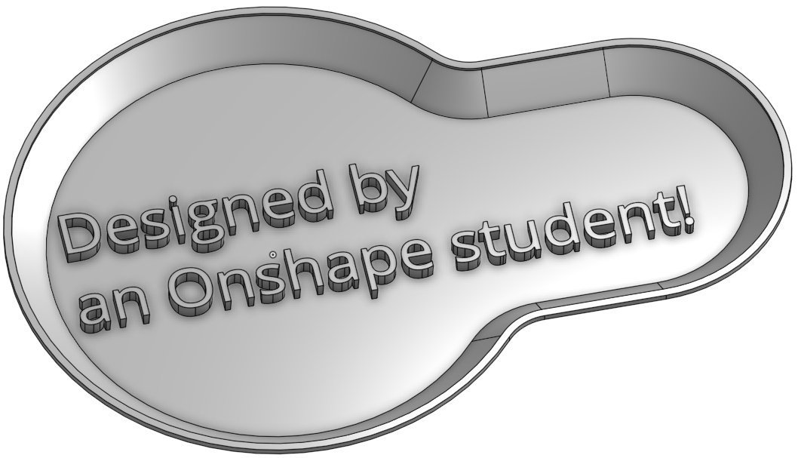

1. Using the CAD models [here](https://cad.onshape.com/documents/3fa393fac2ba5807ebae1d61/w/ecfbcd14db253e714128a69f/e/3f352a87833fd9e59496e700), create the following geometry using sweeps and lofts (with guide curves as needed):
   1. Create this 3-piece HVAC duct using 2 lofts (the one in the middle uses a guide curve from the “Profile” sketch) and a circular extrusion. The thickness is .125”:

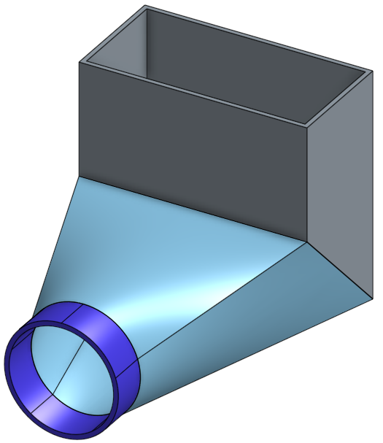

* 1. Create this “curtain” shape with a surface, and thicken it by .06” on each side:

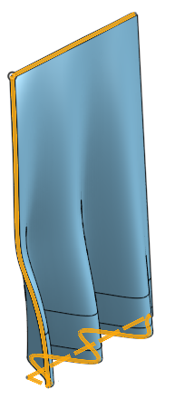

* 1. Complete this umbrella model by first creating the top loft using 8 guide curves, shelling it .050” outwards, and then adding the handle with a sweep feature. Finish off the end of the handle with a nice full round. The model should be made with two parts so they can be colored separately like this:

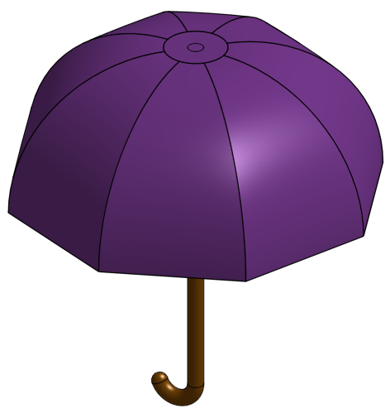

* 1. Complete this 1-5 ACME (1” O.D. X 5 TPI) threaded machined shaft by revolving the shaft, sweeping the thread profile through a helix, and then “cleaning up” the ends. The final shaft should look like this:

